Resource configuration in Pipeline

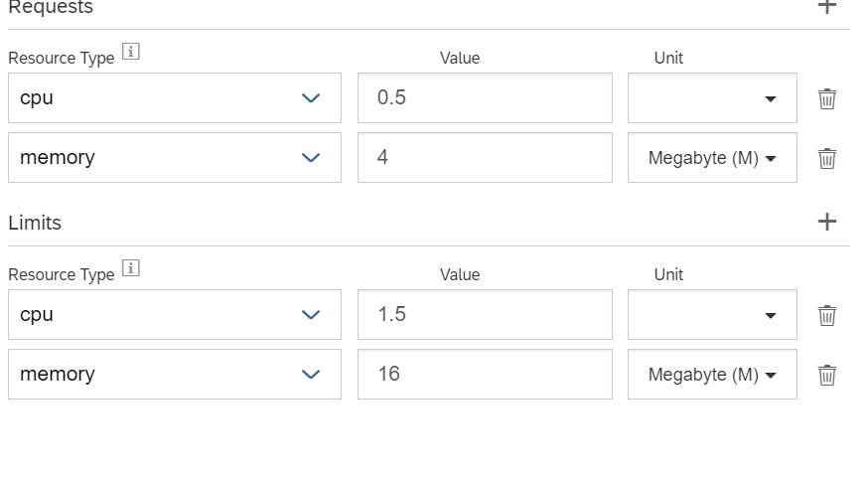

Error coming while executing pipeline with above configuration

